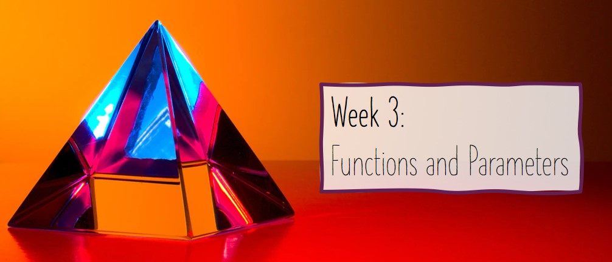

3.7: Defining Functions in Python Worksheet

In this worksheet, you have several questions which require you to write functions which do not have any parameters – the purpose of this worksheet to get you practicing writing functions in Python. I would recommend that you write the pseudocode to help you structure your function – but this is not a compulsory part of this worksheet. If you do not complete this worksheet, you will need to complete it as part of your practice questions this week.

1. Write a function (called metre_conversion()) which takes in a number of metres from the user, then converts it to feet, inches, and yards (all of which are displayed to 2 decimal places) and printing it to the console. Your output should look like this:

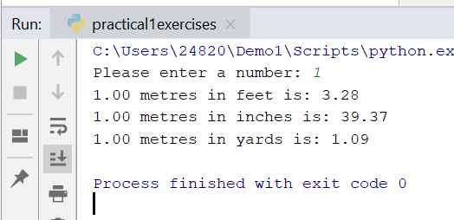

1. Write a function (called acronym_generator()) which takes in a line of text from the user (you can assume that the user will enter 3 words). The program should then output the acronym for the 3 words (the first letter of each word). For example:

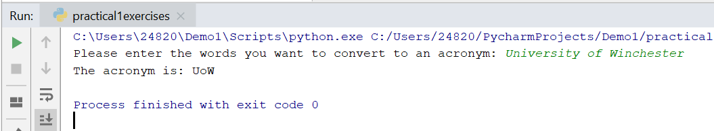

For those of you who have not completed the stretch tasks for next week, look up the split() function which is available for strings.

1. Write a function (with an appropriate name) which asks the user the number of coins they have (1p, 2p, 5p, 10p, 50p, £1, and £2), then prints the total value of the coins they have.
2. Write a function (with an appropriate name) which asks the user to enter the first line of their favourite song, then prints it in reverse. An example of the output is:

